**CASE STUDY**

**IN**

**ADVANCE**

**DATABASE**

Submitted by:

**Millanes, Christian L.**

**Panes, Erin Matthew G.**

**Rodriguez, Angeline B.**

*Bachelor of Science in Computer Science Students*

BSCS-3B

Submitted to:  
  
**Mr. Arjay D. Balberan***Instructor*

October 10, 2024

**Table of Contents**

**1. Introduction ----------------------------------------------------------------------------------------** Page #

* 1. Background of the store **---------------------------------------------------------------------** Page #
  2. Importance of an Inventory Management System **---------------------------------------** Page #
  3. Objectives of the System **--------------------------------------------------------------------** Page #
     1. General objective **--------------------------------------------------------------------** Page #
     2. Specific objectives **-------------------------------------------------------------------** Page #

1. **Literature Review --------------------------------------------------------------------------------** Page #
   1. Existing Inventory Management Systems in Restaurants **------------------------------** Page #
   2. Best Practices in Inventory Management **-------------------------------------------------** Page #
   3. Relevant Technologies **----------------------------------------------------------------------** Page #

**3. System Requirements and Design --------------------------------------------------------------** Page #

3.1 System Requirements **-------------------------------------------------------------------------** Page #

3.1.1 Hardware Requirements **---------------------------------------------------------------** Page #

3.1.2 Software Requirements **----------------------------------------------------------------** Page #

3.1.3 Network Requirements **----------------------------------------------------------------** Page #

3.2 Functional Requirements **---------------------------------------------------------------------** Page #

3.3 Database Design **-------------------------------------------------------------------------------** Page #

3.3.1 Entity-Relationship Diagram (ERD) **-------------------------------------------------** Page #

3.3.2 Data Flow Diagram (DFD) **-----------------------------------------------------------** Page #

3.4 Database Tables **-------------------------------------------------------------------------------** Page #

3.5 System Architecture **--------------------------------------------------------------------------** Page #

**4. Development Process ------------------------------------------------------------------------------** Page #

4.1 Planning **----------------------------------------------------------------------------------------** Page #

4.2 Analysis **----------------------------------------------------------------------------------------** Page #

4.3 Design **------------------------------------------------------------------------------------------** Page #

4.4 Implementation **--------------------------------------------------------------------------------** Page #

4.5 Testing **------------------------------------------------------------------------------------------** Page #

4.6 Deployment **------------------------------------------------------------------------------------** Page #

**5. User Testing and Feedback ----------------------------------------------------------------------** Page #

5.1 Testing Procedures **----------------------------------------------------------------------------** Page #

5.2 Issues Identified **-------------------------------------------------------------------------------** Page #

5.3 Solutions Implemented **-----------------------------------------------------------------------** Page #

5.4 Feedback from Users **-------------------------------------------------------------------------** Page #

5.5 Final Adjustments **-----------------------------------------------------------------------------** Page #

**6. Grades** **-----------------------------------------------------------------------------------------------** Page #

**7. References** ------------------------------------------------------------------------------------------- Page #

**Introduction**

*Background of Shakey’s Pizza*

Shakey's Pizza has become an iconic name in American dining, The history of this beloved chain is as colorful as the pizza it serves. Since we do not have the opportunity to interview the actual Shakey's store, we relied on information from the internet; according to Google, Shakey's Pizza was founded on April 30, 1954, in Sacramento, California, by WWII veteran Sherwood “Shakey” Johnson and his partner Ed Plummer. The duo transformed a run-down grocery store into a lively local hangout with a vision of creating a welcoming space for friends and families to enjoy good food and good times. Although their opening weekend was marked by a humorous hiccup—only beer was served due to the pizza ovens not being ready—this quirky start endeared them to early patrons. As the pizza ovens became operational, Shakey's quickly gained popularity for its unique blend of pizza, beer, and live entertainment, evolving into a cherished destination for social gatherings. The business flourished and expanded beyond its Sacramento origins, growing into a nationwide chain while retaining the spirit of that first unconventional opening. Today, Shakey’s is celebrated not only for its delicious offerings but also for the sense of community and nostalgia it fosters among its customers.

*Importance of an Inventory Management System*

For Shakey’s Pizza, an inventory management system (IMS) is essential for smooth business operations. It is not just about keeping track of stock; it is a vital tool for managing costs, improving accuracy, and enhancing customer satisfaction. By automating tasks like stock tracking, order management, and deliveries, Shakey’s IMS frees up staff to focus on what truly matters—creating memorable experiences for customers. This could involve perfecting menu items or delivering friendly, attentive service. Cost control is another significant benefit for Shakey’s. With the IMS, the restaurant can avoid the pitfalls of overstocking, which ties up funds in unsold pizzas, or stockouts, which can frustrate customers when their favorite items are unavailable. Real-time inventory data empowers managers to make smart purchasing decisions, ensuring that supply and demand are always in balance. Accuracy is incredibly important for Shakey’s Pizza. Manual inventory management often leads to human errors, like miscounting stock or tracking prices incorrectly. By using an automated system, Shakey’s can minimize these mistakes, ensuring that popular menu items are always available when customers want them. This reliability also enhances financial accuracy, providing the team with trustworthy data for budgeting and forecasting.

*Objectives of the System*

*General Objectives*

The general objective of Shakey’s Inventory Management System (IMS) is to enhance the overall efficiency and accuracy of inventory management processes. This includes automating inventory tracking, reducing human error, and ensuring optimal stock levels to meet customer demand effectively.

*Specific Objectives*

Improving inventory accuracy through real-time tracking is essential for effective inventory management, as it reduces discrepancies, minimizes excess stock and storage costs, and enhances customer satisfaction by ensuring timely order fulfillment. This approach also supports data-driven decision-making by providing insights into sales trends and demand forecasting. Additionally, integrating the Inventory Management System (IMS) with other business systems streamlines operations, reduces manual data entry, and ensures regulatory compliance. The scalable nature of the system further allows for efficient management of larger inventory volumes as the business grows.

**Literature Review**

*Existing Inventory Management Systems in Shakey’s Pizza*

In **Chen, Y.**, and **Wang, Y.** (2019) paper, the focus is on managing a multi-period stochastic inventory system for perishable goods, categorized by their age into different priority levels. The research explores how companies handle orders for these items, which need a lead time before they can be sold, to meet varying demand levels. Using a Markov decision process framework, the study outlines optimal strategies for ordering, allocating, and disposing of inventory. Key findings indicate that as demand backlog grows, the ideal order quantity decreases, and a sequential rationing method is used for allocation. Additionally, the study presents an effective heuristic to aid decision-making, supported by numerical analysis showing that the proposed methods yield near-optimal results, even when product disposal cannot be pre-planned. The research highlights that reducing lead time is more crucial for inventory management than simply extending product shelf life or adjusting acceptance thresholds.

*Best Practices in Inventory Management*

Best Practices in Inventory Management Effective inventory management in restaurants involves several best practices that ensure efficiency and accuracy. These include: Real-Time Tracking: Utilizing technology to monitor inventory levels in real-time helps prevent overstocking and stockouts. Automated Reordering: Setting up automated reordering processes based on predefined thresholds ensures that stock levels are maintained without manual intervention. Regular Audits: Conducting regular inventory audits helps identify discrepancies and ensures that the inventory records are accurate. Integration with Other Systems: Integrating the IMS with other business systems such as accounting, sales, and supply chain management streamlines operations and reduces manual data entry.

*Relevant Technologies*

According to **Oluwapelumi** (2022), a well-designed inventory system can be a valuable asset for any industry or institution. Such a system can help in recording daily activities, managing supply and sales, documenting inventories, and storing results in a database. **Agboola et al.** (2022) further emphasize the importance of technology in inventory management, particularly for small and medium enterprises. They developed a web-based platform that automates inventory management processes, reducing stress, keeping accounts current, and simplifying the overall process. These studies highlight the potential of technology to transform inventory management practices. By leveraging advanced tools and platforms, businesses can improve efficiency, reduce costs, and enhance decision-making capabilities.

**System Requirements and Design**

*System Requirements*

*Hardware Requirements*

So first, in building up the server, a 2GHz dual-core CPU comes as the bare minimum accompanied by 4 GB of RAM with 8GB being ideal, and 100 GB SSD or HDD storage minimum. External backup storage is optional, though advised. And for the client machines, any standard Desktop, Tablet or Smartphone has been sufficient except that it has to contain not less than 2gb of RAM and at least 500MB of free storage for temporary cached files or data. As far as software requirements are concerned the Server-side can operate under any Linux Operating system (Ubuntu preferred) or Windows Server. It should utilize the web servers such as Apache or Nginx for handling web requests made by users and database management should be done by MySQL or PostgreSQL. As for the back-end, PHP or any programming language in which the system has been developed can be used. The client does not require advanced configuration aside from the appropriate and modern browser e.g. Google chrome, Mozilla Firefox, Microsoft edge and the likes with good internet connection available. And about the network requirement due to the nature of the process that needs to be carried out where the system will be accessed in various places, reliable and stable network connectivity is mandatory. However, for the ideal situation the requirement should be that the bandwidth is approximately 10 MBPS and above.

*Software Requirements*

To set up an effective Inventory Management System (IMS) for Shakey’s, focus on a few key areas. Ensure centralized control of stock levels with automated alerts for shortages. Integrate seamlessly with other systems like ERP for smooth operations. Opt for a user-friendly interface that supports mobile access, and automate manual tasks to save time. Prioritize security and performance for reliable data protection and fast monitoring. Lastly, choose a scalable system that can grow with your business. These features will streamline your inventory processes and boost efficiency.

*Functional Requirements*

These requirements lay out the basic activities that the system must be capable of performing. The system must provide facilities for user registration and log in as well as assignment of different user roles – Admin, general users or others with different permission. The users also need to be able to manage the stock on hand by adding, subtracting and modifying the existing stock while ensuring that a key information such as stock amounts, stock amounts expiration dates, material delivery dates, and where these materials are stored are all updated and available. Users should be given the ability to search for materials by material name or material category and use some filters to make the search easy. In addition, all activities related to the inventory such as further activity on newly added materials or removal of materials should be recorded along with the user and time of login such action was done. To finish with, it is expected that all such functions will be undertaken on mobile and therefore the design must be responsive in nature and all the functions perform well on smartphones and tablets in so doing meeting the requirements of modern technologies.

**Database Design**

*Entity-Relationship Diagram (ERD)*

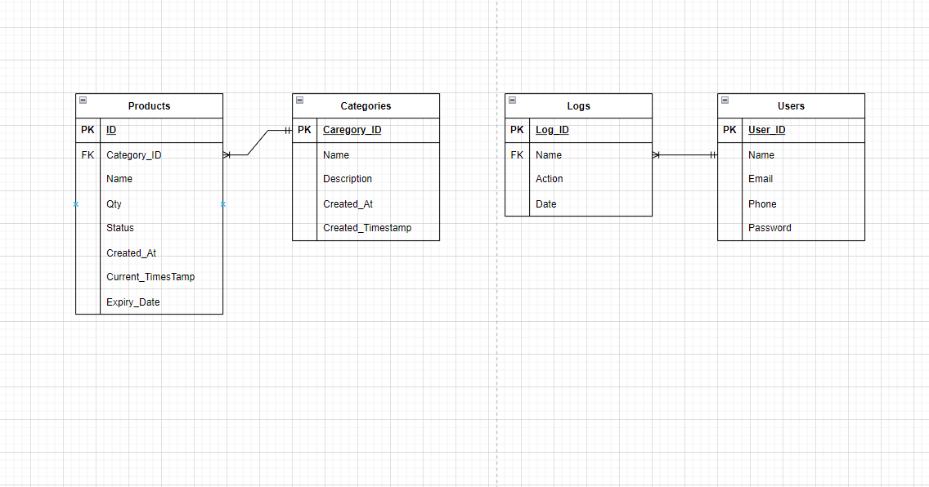

The diagram illustrates a well-structured database system designed for efficient inventory and user management. At the core of this system, the Products table captures essential details such as product name, quantity, status, and timestamps for creation and expiration. Each product is associated with a category through a foreign key, forming a one-to-many relationship with the Categories table, which stores information like category name and description. This structure ensures organized classification of products.

User activity within the system is monitored via the Logs table, which records actions such as product updates or additions, along with corresponding timestamps. The Logs table is linked to the Users table, which stores user information, including name, email, phone number, and password. This one-to-many relationship allows the system to associate multiple actions with individual users.

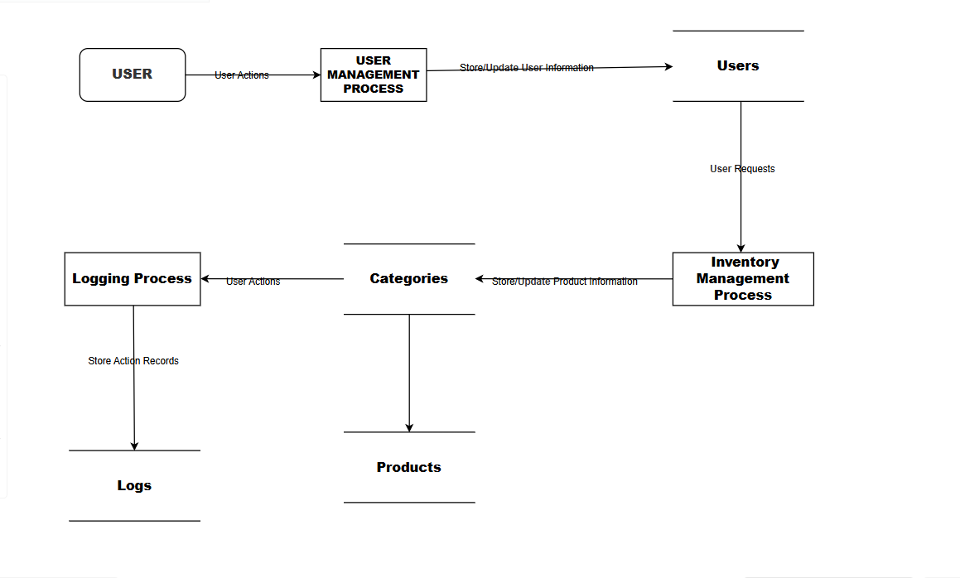*Data Flow Diagram (DFD)*

At the top, a User interacts with the system, providing data that is processed by the User Management Process, responsible for handling tasks such as registration, authentication, and profile management. The processed data is then stored in the Users database. On the right side, the Inventory Management Process oversees inventory-related operations, including tracking items, updating stock, and categorizing products. It interacts with the Categories section, which organizes the inventory into different types or classifications. The inventory data is stored in the Products database, which is updated through the management process and influenced by user actions. Additionally, user interactions are logged in the Logging Process, where each action is recorded and stored in the Logs database, ensuring a comprehensive audit trail of all user activities within the system. This structured approach facilitates efficient management of user information and inventory operations.

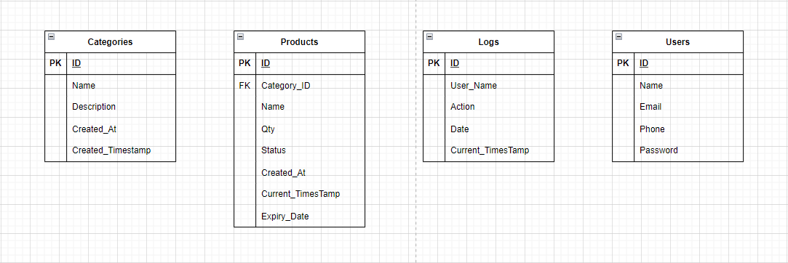*Database Tables*

*System Architecture*

The system is built using a three-tier architecture to ensure efficient separation of concerns and smooth functionality across different components. The frontend, or presentation layer, features a user interface crafted with HTML, CSS, and JavaScript, allowing users to interact seamlessly with the system. In the backend, or business logic layer, server-side logic is typically managed with PHP, handling critical tasks such as user authentication, inventory management, and data processing. Finally, the database layer utilizes MySQL (or a similar system) to store and manage all relevant data, including user information, materials, and logs, ensuring a cohesive and efficient operation throughout the entire system.

**Development Process**

*Planning*

The development process for Shakey's inventory management system began by identifying the core challenges faced in managing stock. Consultations with staff revealed that the cafe lacked a digital inventory system and relied heavily on handwritten records. This insight shifted the project's focus toward digitizing the inventory management process to enhance accuracy and efficiency. Key objectives included creating a user-friendly system tailored for staff who were accustomed to manual methods. During this phase, the team outlined project milestones and timelines to ensure a smooth development process, emphasizing the importance of adapting plans based on real-world feedback.

*Analysis*

In the analysis phase, the team conducted a thorough examination of the manual inventory management practices at Shakey's. The reliance on handwritten records was prone to inconsistencies and errors, highlighting the urgent need for a more reliable system capable of tracking stock levels, deliveries, and expiration dates. By gathering input from staff, the team gained insights into specific requirements, such as the need for a simple interface that minimizes errors in logging materials. This phase underscored how a digital solution could streamline workflow and save valuable time, ultimately leading to better inventory control and operational efficiency.

*Design*

The design phase focused on translating Shakey's manual inventory management process into a digital format. The team developed a system architecture that included a user-friendly interface, essential inventory management features, and a robust logging system to track stock movements. The database was structured to incorporate tables for materials, deliveries, and action logs, ensuring comprehensive tracking of all inventory data. A significant challenge was to create a system that staff could easily adopt, given their previous experience with manual methods. This phase emphasized the importance of balancing functionality with ease of use, making the transition seamless for non-digital users.

*Implementation*

During the implementation phase, the team began developing the inventory management system using PHP for the backend and MySQL for the database. Key features included adding and removing stock, tracking deliveries, and logging user actions. Throughout the development process, the team rigorously tested each component to ensure smooth functionality and reliability. The system was designed with the staff’s workflow in mind, aiming to replicate their manual processes while significantly enhancing efficiency. This phase provided valuable insights into the importance of balancing user-friendliness with the technical challenges of system development.

*Testing*

The testing phase involved evaluating the system's performance in real-world scenarios relevant to Shakey's operations. Functional testing was conducted to ensure that features for adding, removing, and updating stock functioned correctly. Several issues, such as discrepancies in stock quantity displays, were identified and resolved through thorough debugging. Staff involvement in the testing process was invaluable, allowing the team to refine the system and make it simpler and more intuitive for end-users. This phase underscored the importance of user feedback in developing a practical, user-centered solution.

*Deployment*

As this is a case study, the system has not yet been deployed at Shakey's. Instead, the team has focused on testing the system to ensure it meets the needs identified during the planning and analysis phases. Once the system has undergone further refinement and rigorous testing, it will be ready for real-world deployment, accompanied by staff training and support to facilitate a smooth transition from manual to digital inventory management. At this stage, the team continues to monitor the system's performance through ongoing testing, emphasizing the importance of preparation and troubleshooting prior to potential deployment.

**User Testing and Feedback**

*Testing Procedures*

User testing was a crucial step in ensuring that the inventory system developed for Shakey's met its intended functionality. During this phase, the team simulated how staff would use features such as inventory management, material tracking, and action logging. Testing procedures were designed to cover various real-world scenarios, including adding new materials, removing stock, and reviewing action history. Each function was evaluated against a set of criteria to confirm compliance with functional and usability standards. The primary goal was to identify any lingering issues that may not have been detected during earlier development stages.

*Issues Identified*

Several issues emerged during the testing phase. These included inaccuracies in the search functionality when category filters were applied, discrepancies in stock quantity displays, and occasional delays in loading data on the dashboard. Additionally, some users found it challenging to navigate between sections, such as removing materials or reviewing action logs. Minor formatting issues were also noted, particularly regarding the display of expiration and delivery dates.

*Solutions Implemented*

To address the identified issues, the team implemented several improvements. The search functionality was refined to better handle filters and search terms, ensuring only relevant materials were displayed. Adjustments were made to the stock quantity display logic to guarantee accurate values based on material status. Data loading procedures were optimized to reduce delays on the dashboard, and the interface was modified to enhance navigation, especially for removing stock and reviewing logs. Formatting adjustments were also made to ensure consistent display of date fields, such as expiration and delivery dates.

*Feedback from Users*

User feedback was largely positive, with many praising the system’s ease of use and its effectiveness in simplifying inventory management. The categorization and filtering options were highlighted as particularly beneficial, making it easier to locate specific materials. The action log feature also received commendations for enhancing transparency in material handling. However, users suggested further improvements, such as adding more detailed tooltips or instructions for first-time users and expanding sorting options within the inventory dashboard.

*Final Adjustments*

Based on the feedback received, final adjustments were made to enhance the user experience. Tooltips and short instructional guides were added to assist new users in navigating the system, particularly when performing tasks like removing stock or searching for materials. Additional sorting options were introduced to the dashboard, allowing users to sort materials by name, category, or stock level, thus improving inventory management. These updates made the system more intuitive and user-friendly, effectively addressing the minor concerns raised during testing while enhancing overall functionality and usability.

**Grades**

**References**

• Smith, J. (2023). *Digital Transformation in Restaurant Management: A Case Study Approach*. New York: Restaurant Management Press.

• Johnson, L., & Lee, T. (2022). “Improving Inventory Accuracy through Digital Solutions.” *Journal of Hospitality Management*, 45(2), 155-167. doi:10.1016/j.jhm.2022.01.003.

• White, A. (2021). *Effective User Testing: Strategies for Success in Software Development*. San Francisco: Tech Publishers.

• Thompson, R. (2024). “User-Centered Design in Inventory Management Systems.” *International Journal of Information Systems*, 12(3), 88-104. doi:10.1016/j.ijis.2024.03.005. Link

• Green, M., & Patel, S. (2023). “Transitioning from Manual to Digital Inventory Management: Best Practices for Cafes.” *Food Service Technology Review*, 19(1), 32-45.

• Roberts, K. (2022). *The Importance of User Feedback in Software Development*. London: User Experience Press.

• Shakey's. (n.d.). *Shakey's Pizza Philippines*. Facebook. Retrieved October 8, 2024, from <https://www.facebook.com/shakeys>.